International Conference on Applied Mathematics and Computational Fluid Dynamics (ICAMCFD - 2026)
January 30-February 01, 2026, MNNIT Allahabad, Prayagraj, India. (TNR 10 Bold)
ICAMCFD 2026–XXX (Paper ID, 11 Point Arial, Bold)
This is How the Paper Title Should be Written (12 Point Arial, bold)

First Author¹, Second Author², T. Author³, and Fourth C. Author^{2*} (10 Point Arial, bold)

¹Department of Mechanical Engineering, MNNIT Allhabad, Prayagraj -211004, India (10 Point Arial, unbold)
²Department of Applied Mechanics, IIT Delhi, New Delhi-110016, India (10 Point Arial, unbold)
³Department of Chemical Engineering, University of Ottawa, Ottawa, ON, Canada (10 Point Arial, unbold)
first_author@nirmauni.ac.in; s_author@iitd.ac.in; third.author@iitb.ac.in; *corr_auth@iitd.ac.in (10 Point Arial, unbold)

ABSTRACT (10 Point Arial, Bold)
Write your abstract here in 10 point Times New Roman. Limit the abstract within 200 words.

Keywords: Write five keywords here in 10 point Times New Roman.

INTRODUCTION (10 Point Arial, Bold)
Write your introduction section here in 10 point Times New Roman. The introduction part should give the necessary background / motivation behind the work. The citations of others’ work may be bracketed [1-4] appropriately.

LITERATURE REVIEW AND OBJECTIVE (10 Point Arial, Bold)
This subsection should contain the literature review and the objective of the work undertaken Write text matter here in 10 point Times New Roman, unbold. Necessary citations may be bracketed [5-8] appropriately.

(1)
(2)

PROCEDURE AND METHODS (10 Point Arial, Bold)
Write your texts here in 10 point Times New Roman, unbold. This part should contain the necessary matters related to computational, experimental and analytical investigations. Necessary citations may be bracketed [9, 10] appropriately. All Figures / Tables are to be cited within the texts. The Figure/Table captions must be written in Arial 10 point, bold as indicated below. The Figure caption should appear at the bottom of the Figure, while the Table caption should appear on top of the Table. This is the standard practice.

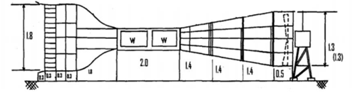
Figure 1: Schematic of set-up (10 Point Arial, Bold).
Table 1: Accuracy of aerodynamic independent variables (10 Point Arial, Bold)

Independent Variables | Accuracy
Combined Rotor torque (T_{rotor}) | $$±1\%$$
Angular velocity of combined rotor $(ω$) | $$±2\%$$
(As indicated above, all the notations are to be italicized and be written in 10 Point Times New Roman, unbold)

  - Subsection (Subsections, if any, should be 10 point Arial, bold but not all-capped).
Write text matter here in 10 point Times New Roman, unbold.

RESULTS AND DISCUSSION (10 Point Arial, Bold)
Discussion of the results is to be written here in 10 point Times New Roman, unbold. All Figures are to be cited within the text. Results obtained may be compared with the published data wherever applicable/possible through necessary citations in bracketed form [11, 12].

  - Subsection (Subsections, should be 10 point Arial, bold but not all-capped).
Write text matter here in 10 point Times New Roman, unbold. All Figures are to be cited within the texts.

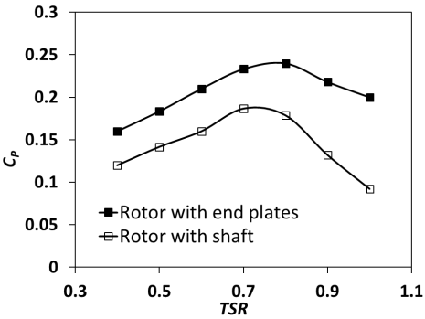
Figure 2: Variation of C_{P} with TSR of the rotors (10 Point Arial, Bold).

CONCLUSIONS (10 Point Arial, Bold)
The key findings of the work are to be placed here in 10 point Times New Roman, unbold. The conclusion part should be qualitative and quantitative.

ACKNOWLEDGEMENTS (10 Point Arial, Bold)
Place any acknowledgements here in 10 point Times New Roman, unbold.

NOMENCLATURE (10 Point Arial, Bold)
A | Frontal area of rotor | [m²]
AR | Aspect ratio | --
C_{D} | Drag coefficient | --
α | Angle of attack | (ᵒ)
ρ | Density of air | [kg/m³]
ω | Rotor rotational speed | [rad/s]
(As indicated above, all the notations are to be italicized and be written in 10 Point Times New Roman, unbold)

REFERENCES (10 Point Arial, Bold)
- T. Ogawa, H. Yoshida, and Y. Yokota, Development of Rotational Speed Control Systems for a Savonius-type Wind Turbine, ASME Journal of Fluids Engineering, 111(1), 1989, p. 53. (All the references are to be written in 10 Point Times New Roman, unbold)
- C. D. Rakopoulos, and E. G. Giakoumis, Second-Law Analyses Applied to Internal Combustion Engine Operation, Progress in Energy and Combustion Science, 32(1), 2006, pp. 2-47.
- M. Eswaran, Waves Simulation in an Excited Cylindrical Tank Using σ-transformation, Paper No. IMECE2010–39752, ASME International Mechanical Engineering Congress and Exposition, November 12–18, 2010, Vancouver, Canada.
- K. M. Hussain, Aerodynamic Performance Evaluation of a Novel Turbine, PhD thesis, Department of Mechanical Engineering, IIT Guwahati, India, 2016.
- ANSYS Inc, ANSYS Fluent Theory Guide 12.0, 2015.
- F. M. White, Fluid Mechanics, McGraw-Hills, New York, USA, 2011.

Notes to Author(s):
- The page limit of a paper is restricted to a maximum of 10 pages.
- In each section, sub-sectioning if required, can be done appropriately.
- Once the paper is compiled, remove all the instructions marked BLUE in this template.
- Also remove this part of Notes to Author(s).
- The plagiarism percentage must be less than 15%.
- Authors are instructed to check plagiarism with the help of Turnitin software before submission in CMT portal.

